11. Emulator on your AAPS Smartphone V 2.0


Please note that with autoISF 3.0 you are in an early-dev. environment, where the user interface is not optimized for safety of users who stray away from intended ways to use. Good safety features exist, but these are only as good as the development-oriented user understands and implements them. This is not a medical product, refer to disclaimer in section 0

The Emulator on the PC discussed in section 10 is very good for making your initial tuning for a meal spectrum, when weighing different effects over the entire course of time after each meal, for a variety of your meals.

A very useful additional tool, is the Emulator running on the AAPS loop smartphone

Installation guide and basic use instructions see here: https://github.com/ga-zelle/APS-what-if/blob/A3.2.0.2_ai3.0_dev/Documentation%20in%20English/A%20%20README.md

the following needs work by .. NN (writing here, and potentially some dev. ) - - - -

11.1 (1) autoISF tab in AAPS main screen or ALTERNATIVE: -> (2)

(Note that these features are not yet available.
For now, even the simplified emulator analysis as proposed in this section 11.1 must be done on the PC, following instructions like e.g. https://github.com/ga-zelle/APS-what-if/blob/A3.1.0.3_ai2.2.8.1/Documentation%20in%20English/How-to-create-the-autoISF-factor-plot.pdf )

The autoISF tab in the AAPS main screen gives access for the past 3-4 hours, of how the various ISFs came into effect.
Hence the table gives clues about which of the weights to modify for any desired effect on SMB sizes add ISF bg; delta and/or pp
AAPS phone display
<- add selected weights
in middle columns
Table scrolls through display
(landscape oriented)

Tbd DEV: (1) give ISFs or factors on profile ISF in middle columns? (2) define color highlights
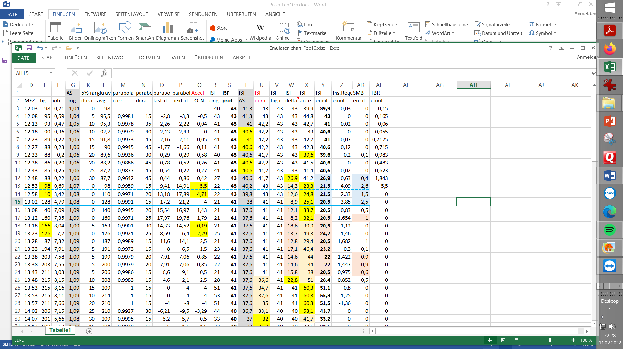

Additionally, key info from this table is presented in graphical form: like this example (by ga-zelle; LC - try to get picture fitting table above - with 3 different _ISFs contributing strongly to SMB -over time )
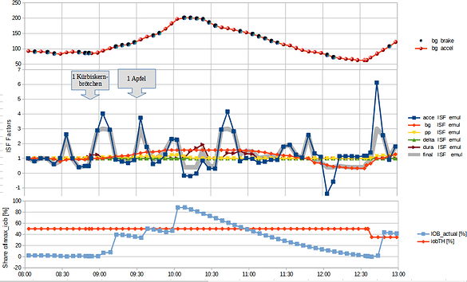

11.1 (2) autoISF charts in AAPS main screen (ALTERNATIVE)

autoISF-related charts can be activated below the glucose chart in the AAPS home screen (below IOB, SENS etc) to give access to how the various ISFs came into effect in the past 3-4 hours,

Hence the graph / table / data similar to those suggested in the preceding section 11.1 (1) gives clues about which of the weights to modify for any desired effect on SMB sizes

- ( can we add pictures from prototype ga-zelle ? )

11.2 Real-time checking a „what-if“ question using speech synthesis

The emulator on your smartphone can help clarify a "what if..." question.

In running the Emulator on the phone, one can define in the .vdf file of the Emulator, which setting one would like to be differently aggressive than in the active AAPS.

At times when this different setting would have resulted in smaller or greater SMB insulin delivery, the notification is reported via speech synthesis, and you can assess the situation in real-time yourself. If for instance a suggested extra or bigger SMB makes sense, you can add this portion manually* ….and in time observe, whether this bolus was OK and you should switch to the different setting you were investigating.

*In Full Closed Loop, you don't need any buttons at the bottom of the AAPS main screen. But for such test phases it is practical to reinstall the insulin button at the bottom of the AAPS main screen (Preferences/Overview/Buttons/Insulin -> ON).

After a few iterations, you'll get a feel for whether you want to incorporate this tightening into the active AAPS.

Warning: Your settings must always work for a variety of meals. Do not put too much effort into optimizing one situation!

( add link to more info AND more info here, and / or a case study )

